HOUSEHOLD CHORE & DUTY PLANNER
@CREATIVITY THINK (9483175986/7019689991)

ABSTRACT:
The Household Chore & Duty Planner is a web-based application designed to organize and streamline daily household responsibilities among family members, roommates, hostel residents, and shared living groups. The system includes a shared chores calendar, recurring task scheduling, reminders, and a gamified points-and-rewards model to encourage consistency. Users can mark tasks as completed, track streaks, and view weekly summaries, while administrators configure chore templates, adjust point rules, moderate disputes, and view engagement statistics through a dashboard. Built using Django REST Framework for the backend and React with Recharts for the frontend, the platform ensures a smooth, interactive, and collaborative task-management experience..

INTRODUCTION OF THE PROJECT:
Managing daily chores in shared households can often lead to miscommunication, uneven distribution of responsibilities, and conflicts. Traditional manual tracking systems such as physical charts or verbal reminders are inefficient and lack historical data. The Household Chore & Duty Planner provides a central digital system to track duties, assign recurring tasks, monitor completion, and encourage participation through gamified points.
The system ensures transparency, equal workload distribution, and motivation through a user-friendly interface equipped with analytics, weekly summaries, and reminders..

PROJECT OBJECTIVES:

• Allow creation of family or roommate groups for chore sharing
• Enable adding members and assigning daily or recurring tasks
• Provide a shared chores calendar for structured planning
• Implement gamification with points, streaks, and rewards
• Provide reminders and notifications for due chores
• Generate weekly summaries for group performance
• Allow admins to configure chores, points, and dispute resolutions
• Include simple analytics for engagement and participation
• Support exporting lightweight group reports

PROBLEM OF THE STATEMENT:
Shared households often struggle with unequal distribution of tasks, forgotten responsibilities, and poor coordination. Without a proper structure, conflicts arise about who completed which chore and when. This project solves the issue by offering a centralized planner with recurring tasks, automated reminders, points for motivation, and transparent tracking. It enhances cooperation, fairness, and accountability within shared living environments..

MOTIVATION OF THE PROJECT:
• Promote organized task-sharing in families and shared flats
• Reduce conflicts related to chores and responsibilities
• Encourage consistent participation through gamification
• Replace manual tracking systems with a digital planner
• Provide a fun, interactive way to manage duties
• Increase household harmony and efficiency
• Offer analytical insights into engagement trends

BLOCK DAIGRAM OF PROJECT:

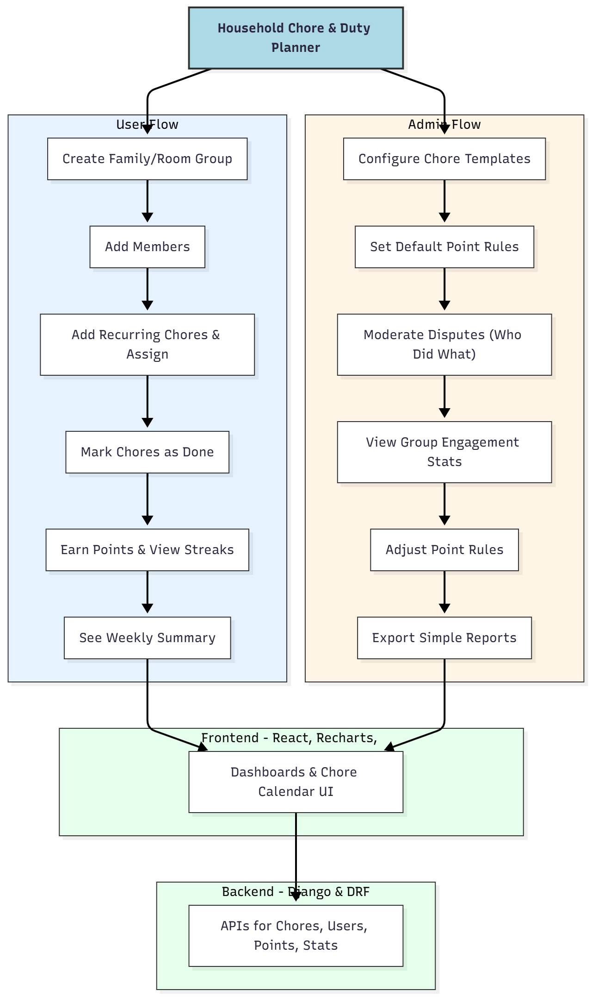

WORKING OF THE PROJECT:
Users begin by creating a family or shared-room group, after which members are added to the system. Chores—daily or recurring—are assigned to individuals. As members complete tasks, they mark them as done, which updates streaks and awards points.
The system generates summaries to display group performance and individual contribution.
Admins act as moderators: they define chore templates, adjust point rules, handle disputes about task completion, and review engagement analytics such as charts and participation frequency.
The dashboard also allows exporting simple reports summarizing weekly or monthly household performance..

SOFTWARE REQUIREMENT:
- Backend:
  - Python 3.x
  - Django
  - Django REST Framework
  - SQLite/PostgreSQL
- Frontend:
  - Node.js and npm
  - React.js
  - Axios
- Development Tools:
  - Visual Studio Code
  - Postman (for testing APIs)
  - Git/GitHub (for version control)
- Server/Deployment (Optional):
  - Gunicorn, Nginx, or Heroku/AWS for hosting

ADVANTAGES OF THE PROJECT:

• Ensures fair distribution of household tasks
• Increases motivation with gamified points and streaks
• Reduces conflicts through transparent tracking
• Strengthens coordination in families and shared living
• Provides useful weekly insights and simple analytics
• Easy to use and accessible from any browser
• Helps maintain long-term consistency in chores
• Fun and engaging for all age groups

APPLICATIONS OF THE PROJECT:
• Families at home
• Shared student accommodation
• Hostel residents
• PGs and shared rental flats
• Any group needing structured chore assignment

REFERENCES:

- Django REST Framework Documentation — Django Software Foundation. Django Documentation. Available: https://docs.djangoproject.com/
- Django REST Framework. DRF Documentation. Available: https://www.django-rest-framework.org/
- React. React Official Documentation. Available: https://reactjs.org/docs/getting-started.html
- Redux. Redux Documentation. Available: https://redux.js.org/introduction/getting-started
- PostgreSQL Global Development Group. PostgreSQL Documentation. Available: https://www.postgresql.org/docs/
- MySQL. MySQL Reference Manual. Available: https://dev.mysql.com/doc/
- Git. Git Documentation. Available: https://git-scm.com/doc
- Node.js. Node.js Documentation. Available: https://nodejs.org/en/docs/
- Axios. Axios Documentation. Available: https://axios-http.com/docs/intro
- Socket.io Documentation – https://socket.io/docs/

